HOLY HEARTS EDUCATIONAL ACADEMY
FINAL TERM EXAMINATION
SUBJECT – Biology

Time Allowed: 3 hours Maximum Marks: 70
General Instructions:
- All questions are compulsory.
- The question paper has five sections and 33 questions. All questions are compulsory.
- Section–A has 16 questions of 1 mark each; Section–B has 5 questions of 2 marks each; Section– C has 7 questions of 3 marks each; Section– D has 2 case-based questions of 4 marks each; and Section–E has 3 questions of 5 marks each.
- There is no overall choice. However, internal choices have been provided in some questions. A student has to attempt only one of the alternatives in such questions.
- Wherever necessary, neat and properly labeled diagrams should be drawn.

Section A
- International Code of Biological Nomenclature is applied to_______. [1]
a) Plants b) Both Plants and Animals
c) Virus d) Animals
- The adult human kidney is metanephric. So, first embryonic tubules formed in vertebrates during embryonic development are: [1]
a) Pronephric b) Amphinephric
c) Metanephric d) Mesonephric
- Proteins are made up of___________. [1]
a) Nucleosides b) Monomers
c) Heteropolymers d) Homopolymers
- In dicot stems, the cells of cambium present between the primary xylem and primary phloem are: [1]
a) Vascular cambium b) Interfascicular cambium
c) Medullary cells d) Intrafascicular cambium
- Which of the following is not correctly matched? [1]
a) Inspired air = Alveolar air b) Respiration = Physiochemical process
c) TLC = VC + RV d) Cutaneous respiration = Breathing via skin
- On excitation, the electrons picked up by an electron acceptor is passed to _______. [1]
a) photons b) cytochromes
c) reaction centre d) anntenae
- The filtration fraction is the ratio of GFR to RPF where both the values are in ml/min and FF is expressed in percentage. Calculate FF for a normal adult human being, if RPF= 600ml/min: [1]
a) 2.08% b) 10.38%
c) 20.73% d) 20.83%
- The lymph in frog lacks: [1]
a) RBC and plasma b) Plasma and WBCs
c) WBCs and few proteins d) RBCs and few proteins
- Plant growth regulator that is used in delay in leaf senescence is_______. [1]
a) Ethylene b) Cytokinin
c) Auxin d) ABA
- Which plant division is known as amphibians _________. [1]
a) Gymnosperms b) Thallophyta
c) Bryophytes d) Angiosperms
- Which of the following animals shows ammonotelic excretion? [1]
a) Cat b) Sparrow
c) Human d) Rohu
- Expiration will take place when there is: [1]
A. Positive intrapulmonary pressure
B. Negative intrapulmonary pressure
C. Less pressure within lungs as compared to atmospheric pressure
a) (C) b) (A)
c) (B) and (C) d) (B)
- Assertion (A): The mycelium is coenocytic in Zygomycetes. [1]
Reason (R): The gametes are uninucleate.
a) Both A and R are true and R is the correct b) Both A and R are true but R is not the explanation of A. correct explanation of A.
c) A is true but R is false. d) A is false but R is true.
- Assertion (A): Oxygenation of blood promotes the release of carbon dioxide from the blood in the lungs.
Reason (R): Carbon dioxide is carried as bicarbonates in erythrocytes of blood. [1]
a) Both A and R are true and R is the correct b) Both A and R are true but R is not the explanation of A. correct explanation of A.
c) A is true but R is false. d) A is false but R is true.
- Assertion (A): Proenzyme is the precursor of an enzyme. [1]
Reason (R): Proenzyme is as active as the enzyme.
a) Both A and R are true and R is the correct b) Both A and R are true but R is not the
explanation of A. correct explanation of A.
c) A is true but R is false. d) A is false but R is true.
- Assertion (A): Excessive inflation of the lungs is prevented by the Hering-Breuer reflex. [1]
Reason (R): On overstretching of the lungs, the stretch receptors send impulses along the vagus nerve to stimulate the expiratory centre.
a) Both A and R are true and R is the correct b) Both A and R are true but R is not the explanation of A. correct explanation of A.
c) A is true but R is false. d) A is false but R is true.

Section B
- Write one difference between mesophyll of dicot leaf and a monocot leaf. [2]
- How does a gap junction facilitate intercellular communication? [2]
- Comment hormones are called informational molecules. [2]
- What is a taxon? [2]
- What do you understand by biosynthetic phase of photosynthesis? [2]
OR
What is non-cyclic photophosphorylation?

Section C
- Describe the important characteristics of gymnosperms. [3]
- Differentiate between: [3]
a. Open and closed circulatory system
  - Oviparity and viviparity
  - Direct and indirect development
- Differentiate between nucleosides and nucleotides. Give one example for each. [3]
- Both animals and plants grow. Why do we say that growth and differentiation in plants is open and not so in animals? Does this statement hold true for sponges also? [3]
- Write the difference between red and white muscles. [3]
- What are SA and AV nodes? What are their functions? [3]
OR
Explain heart sounds.
- Suppose for some reason ATP falls deficient in nerve fibre, how will it affect the conduction of nerve impulse through it? [3]

Section D

29. Read the following text carefully and answer the questions that follow: [4]
The fungi constitute a unique kingdom of heterotrophic organisms. They show a great diversity in morphology and habitat. Fungi are cosmopolitan and occur in air, water, soil, and on animals and plants. They prefer to grow in warm and humid places. Most fungi are heterotrophic and absorb soluble organic matter from dead substrates and hence are called saprophytes. When a fungus reproduces sexually, two haploid hyphae of compatible mating types come together and fuse. In some fungi, the fusion of two haploid cells immediately results in diploid cells
(2n). The fungiform fruiting bodies in which reduction division occurs, leading to the formation of haploid spores. Symbionts - in association with algae as lichens and with roots of higher plants as mycorrhiza.
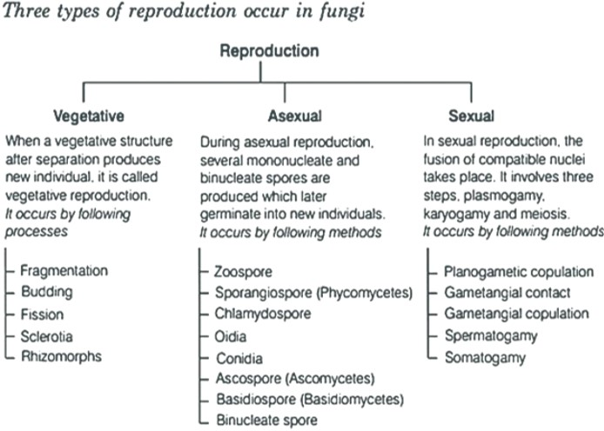
- Observe the given flow chart of reproduction and mention which steps involves in the sexual cycle of fungi. (1)
- What is Rhizopus? Also, mention Rhizopus - wheat rush a correct match? (1)
iii. What is Mycorrhiza? And mention its function. (2)
OR
In which form Fungi Stores Food Material? Do fungi have food vacuoles? (2)

Read the following text carefully and answer the questions that follow: [4]
Each flower normally has four floral whorls, viz., calyx, corolla, androecium and gynoecium. The calyx is the outermost whorl of the flower and the members are called sepals. Corolla is composed of petals. Petals are usually brightly coloured to attract insects for pollination. The mode of arrangement of sepals or petals in floral bud with respect to the other members of the same whorl is known as aestivation. The main types of aestivation are valvate, twisted, imbricate. The shape and colour of corolla vary greatly in plants. Corolla may be tubular, bell- shaped, funnel-shaped or wheel-shaped and vexillary.
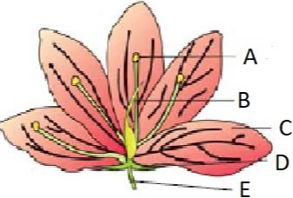
- Observe the given figure mentioned A, B, C and D. Also mention its function. Identify D and mention its
example. (1)
- Ganosepalous, Ganopetalous, Polysepalous, Polypetalous, Imbricate. (1)
- What is Valvate and twisted aestivation? (2)

OR
Which of the following shows imbricate? Explain imbricate aestivation? (2)
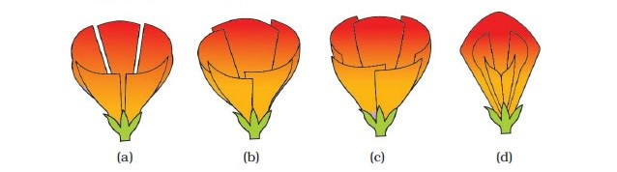

Section E
- What are the various stages of meiotic prophase-I? Enumerate the chromosomal events during each stage? [5]
OR
Comment on the statement - Meiosis enables the conservation of specific chromosome number of each species even
though the process per se, results in reduction of chromosome number.
- Define and explain the process of fermentation in animals, yeast and bacteria. [5]
OR
Enumerate the assumptions that we have undertaken in making the respiratory balance sheet. Are these assumptions valid for a living system?
- What structural and functional attributes must a cell have to be called a living cell? [5]
OR
Describe the steps involved in karyokinesis of meiosis I

